Project 2: Bike Rental Prediction

# Step 1: Exploratory Data Analysis (EDA)

**1: Load the Relevant Libraries**

# A close-up of a computer screen Description automatically generated2: Load the dataset

# Data Type Conversion

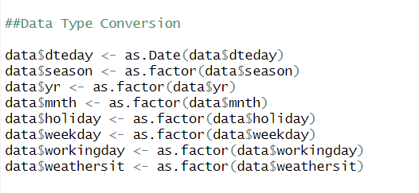

# Missing Value Analysis

# Monthly Distribution of Total Bikes Rented

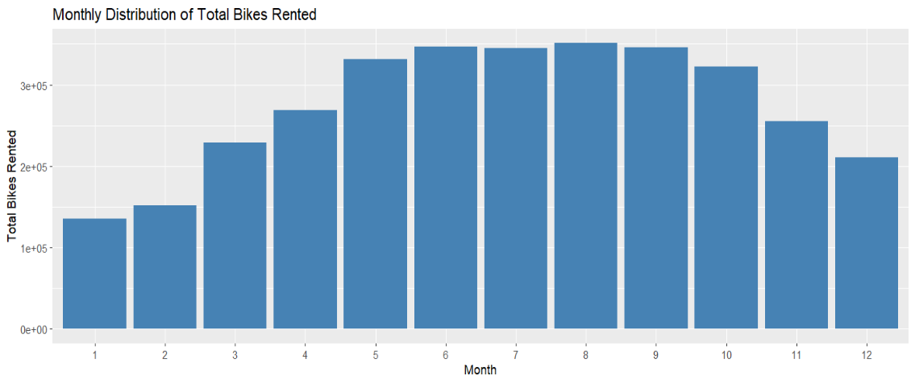

# Yearly Distribution of Total Bikes Rented

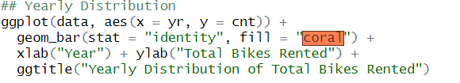

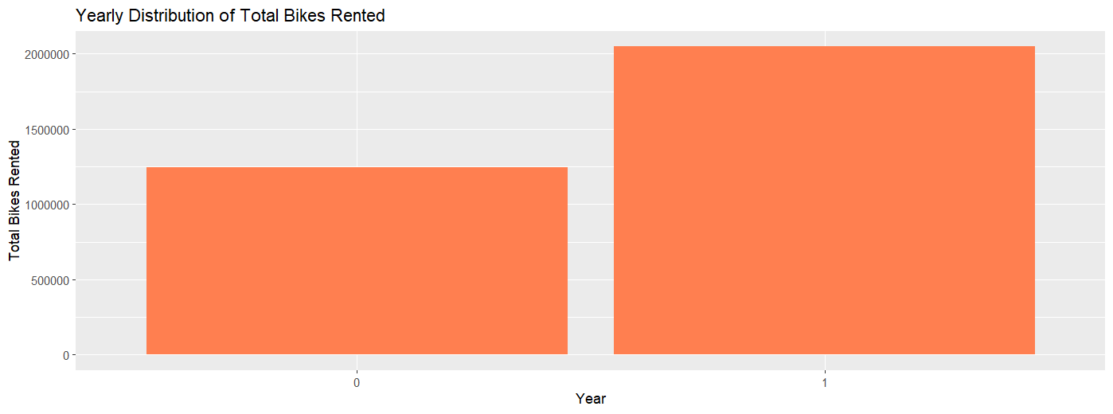

# Boxplot for Outliers Analysis

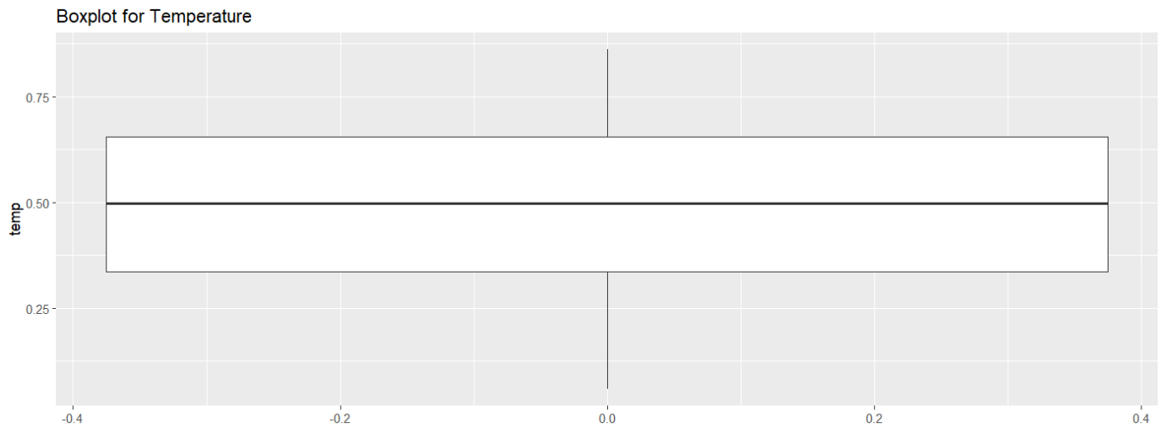

# Step 4: Split the Dataset into Train and Test Dataset

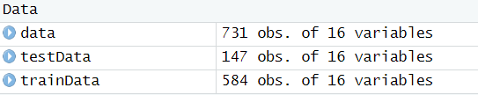

# 5: Create a Model Using the Random Forest Algorithm



# Step 6: Predict the Performance of the Model on the Test Dataset



To evaluate the model, you could calculate metrics such as Mean Squared Error (MSE), Root Mean Squared Error (RMSE), or Mean Absolute Error (MAE). These metrics provide insight into the model's accuracy.

#Project Outcome By following these steps, you will load the dataset, perform EDA to understand the data's characteristics, visualize the distribution of bike rentals, prepare the data, build a random forest model, and evaluate its performance. This process will equip you with insights into factors affecting bike rentals and allow you to predict future rentals accurately.

Remember, the effectiveness of your model might depend on various factors, including the quality of the data, the selection of variables included in the model, and how well the model's assumptions fit the data. Continuous refinement and validation against new data are key to maintaining the model's accuracy over time.